ASSIGNMENT – GCN
Graph Convolutional Network

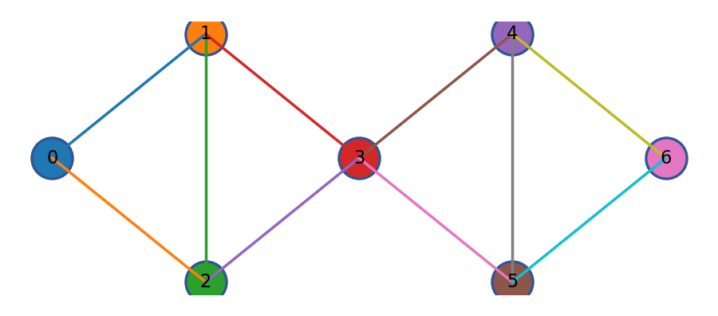

Submitted by
Chittaloori Likhitha
CB.SC.P2AIE26009
Technical Report: Two-Layer and Three-Layer Vanilla GCN

Abstract
This report documents two graph convolutional network implementations written in Java: a two-layer Vanilla GCN evaluated on the Cora citation network and a three-layer Vanilla GCN evaluated on CiteSeer. Both tasks represent papers as graph nodes, use paper attributes as node features, and use citation links to define graph connectivity. The implementations load the citation datasets, create undirected graph structures with self-loops, normalize graph connectivity, train the network with supervised labels, monitor validation performance, and evaluate predictions on held-out test nodes. The report describes the graph-learning concepts, dataset handling, architecture, optimization, saved predictions, evaluation measures, and limitations. The code listings are included in full from the supplied project archive. All reported metrics are calculated from the supplied saved prediction files or read from the supplied model metrics file; no additional model training is performed for this report.
Keywords: Graph Neural Networks, Graph Convolutional Network, Vanilla GCN, Cora, CiteSeer, semi-supervised node classification, citation network, confusion matrix, macro-F1.

Report organization
Section | Content
1 | Introduction, problem statement, and objectives
2 | Graph learning and Vanilla GCN foundations
3 | Datasets and implementation methodology
4 | Two-Layer GCN on Cora: architecture, results, interpretation, and complete code
5 | Three-Layer GCN on CiteSeer: architecture, results, interpretation, and complete code
6 | Cross-experiment discussion, limitations, conclusion
Appendix A | Complete supporting Java and Python files supplied in the ZIP

1. Introduction
Many machine-learning problems contain relationships between data items, not only independent feature vectors. Citation networks are an example: each paper has textual or binary attributes and also cites other papers. A conventional model that treats every paper independently can use node attributes but does not directly aggregate information from connected papers. A graph neural network represents both kinds of information and learns representations that depend on a node and its neighborhood.
A Graph Convolutional Network (GCN) performs neighborhood aggregation using a normalized adjacency matrix. At each layer, node representations are transformed by trainable weights and combined with graph structure. Hidden layers can learn increasingly contextual representations, while the final layer produces class scores. This report focuses on the Vanilla GCN approach implemented in the supplied Java code rather than attention-based or sampling-based alternatives.
The project contains two experiments: a two-layer GCN applied to Cora and a three-layer GCN applied to CiteSeer. They are documented as separate experiments because the datasets and model configurations differ. The report does not interpret the results as a controlled layer-count comparison.

1.1 Problem statement
The problem is semi-supervised node classification on citation graphs. Each paper is represented by a feature vector and belongs to one subject category. Only a subset of nodes is used for training; validation nodes support model monitoring and test nodes are reserved for final evaluation. The objective is to predict paper categories by learning from node attributes and graph connectivity.

1.2 Objectives
- Represent citation datasets as graphs with feature-bearing nodes and citation edges.
- Implement graph convolution and model training directly in Java.
- Train a two-layer GCN on Cora and a three-layer GCN on CiteSeer.
- Track validation performance and save test-set predictions and training logs.
- Evaluate predictions using accuracy, macro precision, macro recall, macro F1-score, per-class metrics, and confusion matrices.
- Interpret observed strengths and limitations without inventing experiments.

1.3 Scope
The report covers the code and result artifacts present in the uploaded ZIP. It includes the two primary model files and the supporting dataset-loader and visualization scripts. The report does not claim a reproducible independent rerun; it analyzes the existing saved outputs. The report intentionally omits a References section as requested.

2. Graph-learning foundations

2.1 Graph representation
A graph can be represented as G = (V, E), where V is the set of nodes and E is the set of edges. In a citation network, a node represents a paper and an edge represents a citation relation. A feature matrix X stores one row per paper. A label vector y stores the class index associated with each paper. The adjacency matrix A encodes whether node pairs are connected.
For an undirected graph, a citation relation is represented in both directions. The code also adds a self-loop to each node. Self-loops allow the aggregation operation to retain information from the node itself instead of using only neighboring nodes.

2.2 Graph convolution
A commonly used Vanilla GCN layer is expressed as:
H⁽ˡ⁺¹⁾ = σ(Ã H⁽ˡ⁾ W⁽ˡ⁾ + b⁽ˡ⁾)
Here H⁽ˡ⁾ is the representation matrix at layer l, W⁽ˡ⁾ is the trainable weight matrix, b⁽ˡ⁾ is a bias term, σ is an activation function, and Ã is the normalized adjacency matrix. In the supplied code, ReLU is used for hidden layers and softmax converts final logits to class probabilities.

2.3 Self-loops and symmetric normalization
Ã = D̃⁻¹ᐟ² (A + I) D̃⁻¹ᐟ²
I is the identity matrix, and D̃ is the degree matrix of A + I. Symmetric normalization scales messages according to node degrees and is the standard normalization pattern visible in the implementation. The exact implementation is described in the relevant code section.

2.4 Hidden transformations and output
For a two-layer model, the conceptual sequence is input features → graph aggregation and hidden projection → ReLU → graph aggregation and class projection → softmax probabilities. For a three-layer model, an additional hidden transformation is inserted before the output layer. More layers can allow information to travel across a larger graph neighborhood, but additional depth does not guarantee improved performance; optimization difficulty and over-smoothing can also affect results.

2.5 Training objective
The implementations calculate cross-entropy loss over training nodes. For a node with true class yᵢ and predicted probability pᵢ,yᵢ, the loss contribution is −log(pᵢ,yᵢ). The average is calculated over nodes selected by the training mask. L2 regularization is applied to weight gradients in the code. Gradient updates use the configured learning rate.

2.6 Evaluation metrics
Metric | Meaning | Interpretation
Accuracy | Correct predictions divided by all evaluated predictions. | Overall fraction of correct test predictions.
Precision | TP / (TP + FP) for a class. | Of the nodes predicted as a class, how many were correct.
Recall | TP / (TP + FN) for a class. | Of the true nodes in a class, how many were found.
F1-score | Harmonic mean of precision and recall. | Balances false positives and false negatives.
Macro precision / recall / F1 | Unweighted average across classes. | Gives each class equal weight, useful when class performance differs.
Confusion matrix | Counts true classes against predicted classes. | Shows which categories are correctly classified or confused.

3. Datasets and experimental workflow

3.1 Cora
The Cora dataset in the ZIP contains `cora.content`, `cora.cites`, a README, and an archived dataset file. Each content record provides a paper identifier, a feature vector, and a class label. The citation file provides pairs of paper identifiers. The supplied two-layer model uses these files from `dataset/cora/`. The saved test prediction file contains 548 evaluated papers and seven subject labels.
The dataset classes observed in the saved predictions are Case_Based, Genetic_Algorithms, Neural_Networks, Probabilistic_Methods, Reinforcement_Learning, Rule_Learning, and Theory. The model's saved prediction file is the source for the test-set metrics presented below.

3.2 CiteSeer
The CiteSeer dataset in the ZIP contains `citeseer.content`, `citeseer.cites`, a README, and an archived dataset file. The supplied three-layer model reports 3,312 nodes, 3,703 features per node, and six classes. Its saved split contains 1,984 training nodes, 660 validation nodes, and 668 test nodes. The Java output notes that 17 citation links had unknown paper identifiers and were ignored during graph construction.

3.3 Workflow
- Read node feature records and class labels from the content file.
- Map paper identifiers to internal node indices.
- Read citation pairs and retain links whose paper identifiers are known.
- Build the graph representation, make the graph undirected, add self-loops, and normalize adjacency.
- Create stratified train, validation, and test masks using the fixed random seed in the code.
- Initialize trainable weights, run forward propagation, calculate training loss, backpropagate gradients, and update weights.
- Monitor validation accuracy and macro-F1, retain the best model according to validation macro-F1, and save training logs.
- Evaluate the selected model on test nodes and save predictions and metric outputs.

3.4 Reproducibility notes
Both model files use a fixed seed value of 42 and define their hyperparameters in source code. The two-layer model is configured for 300 epochs, hidden size 32, learning rate 0.005, and L2 coefficient 0.0005. The three-layer model is configured for 200 epochs, hidden sizes 32 and 16, learning rate 0.01, and L2 coefficient 0.0005. These are the source-code settings; the report does not imply that the two experiments use identical hyperparameters.
Setting | Two-Layer GCN / Cora | Three-Layer GCN / CiteSeer
Input feature count | Read from Cora content file; 1,433 features in standard Cora format | 3,703 (reported by saved run)
Number of classes | 7 | 6
Hidden dimensions | 32 | 32, then 16
Epochs | 300 | 200
Learning rate | 0.005 | 0.01
L2 coefficient | 0.0005 | 0.0005
Random seed | 42 | 42
Train/validation/test | Stratified 60/20/20 split in source | Stratified 60/20/20 split in source

4. Two-Layer GCN on Cora
This section documents the Cora experiment before the CiteSeer experiment, as requested.

4.1 Experiment overview
The two-layer model is implemented in `TwoLayerGCN.java`. It loads the Cora content and citation files, creates graph data structures, constructs an undirected graph with self-loops, applies symmetric adjacency normalization, and trains a two-layer graph convolution model. The source defines a hidden dimension of 32, 300 epochs, learning rate 0.005, L2 coefficient 0.0005, and random seed 42.

4.2 Architecture
The first layer transforms the 1,433-dimensional paper feature vector into a 32-dimensional hidden representation after graph aggregation and ReLU activation. The second graph convolution transforms hidden representations into seven class logits. Softmax produces class probabilities. Training uses only nodes marked by the training mask; validation data is used for monitoring and test nodes are used for final prediction.
Figure 4.1. Conceptual graph illustration; this is explanatory artwork, not a plot of the actual Cora network.

4.3 Saved test results
The supplied `results/predictions.csv` contains 548 test-set predictions. Recomputing the evaluation metrics from its actual and predicted labels gives an accuracy of 0.2573, macro precision 0.0852, macro recall 0.1579, and macro F1-score 0.1048. These values are derived from the saved prediction file in the ZIP, not from a new training run.
Metric | Value
Test predictions | 548
Accuracy | 0.2573
Macro precision | 0.0852
Macro recall | 0.1579
Macro F1-score | 0.1048

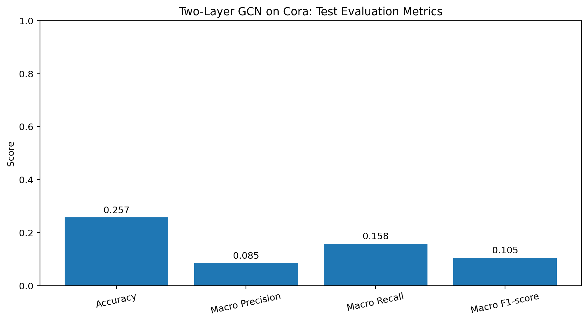
Figure 4.2. Overall test evaluation metrics calculated from the saved Cora predictions.
Interpretation: the saved predictions show limited overall classification performance. Accuracy is approximately 25.73%, and macro F1 is approximately 0.105. Macro precision is low because some classes receive few or no correct predictions. These results are presented as recorded, not improved or altered for the report.

4.4 Per-class metrics
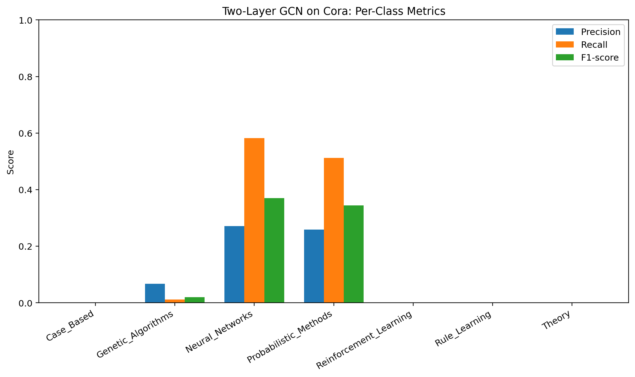
Figure 4.3. Precision, recall, and F1-score by Cora class.
Class | Precision | Recall | F1-score
Case_Based | 0.0000 | 0.0000 | 0.0000
Genetic_Algorithms | 0.0667 | 0.0118 | 0.0200
Neural_Networks | 0.2712 | 0.5818 | 0.3699
Probabilistic_Methods | 0.2588 | 0.5116 | 0.3438
Reinforcement_Learning | 0.0000 | 0.0000 | 0.0000
Rule_Learning | 0.0000 | 0.0000 | 0.0000
Theory | 0.0000 | 0.0000 | 0.0000

The per-class scores show that the model performs unevenly. Neural_Networks and Probabilistic_Methods receive the strongest F1-scores among the classes in the saved test predictions. Several other classes have zero F1 because the model does not produce a correct prediction for those classes in this test file. This pattern indicates that overall accuracy alone does not describe the model's class-level behavior.

4.5 Confusion matrix
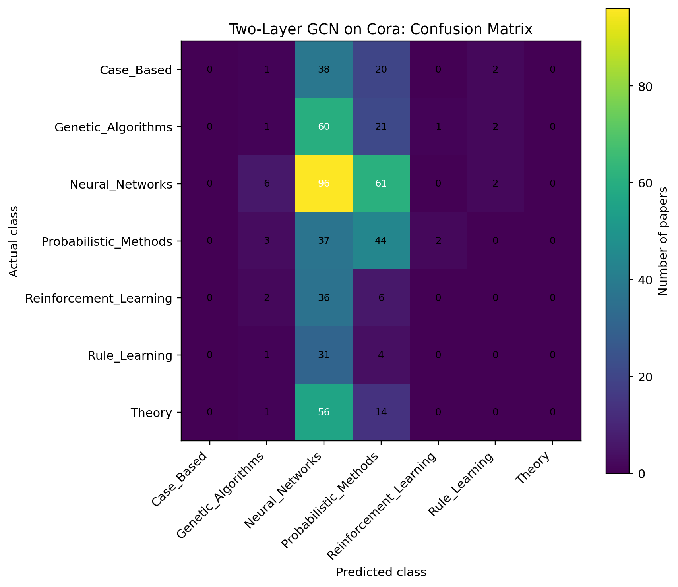
Figure 4.4. Confusion matrix for the Cora test predictions; rows are actual classes and columns are predicted classes.
The matrix indicates substantial confusion toward Neural_Networks and Probabilistic_Methods. The model rarely or never predicts some other categories correctly. Off-diagonal counts represent test papers assigned to a class different from their true label. The figure is useful for diagnosing class-specific errors and motivates checking training stability, feature processing, class balance, and implementation behavior before drawing broad claims.

4.6 Training and validation plots
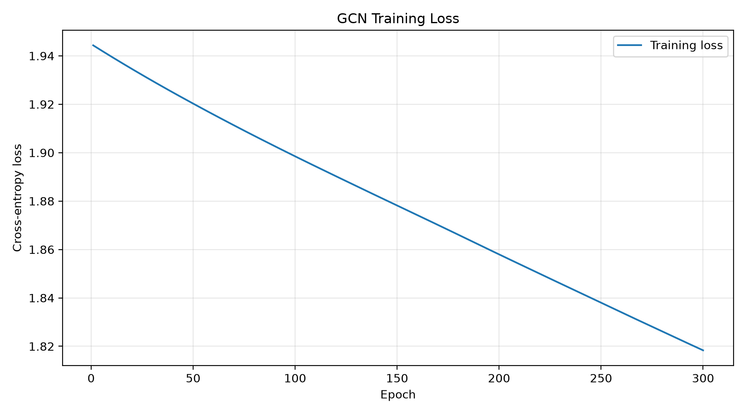
Figure 4.5. Training loss curve saved by the supplied visualization script.
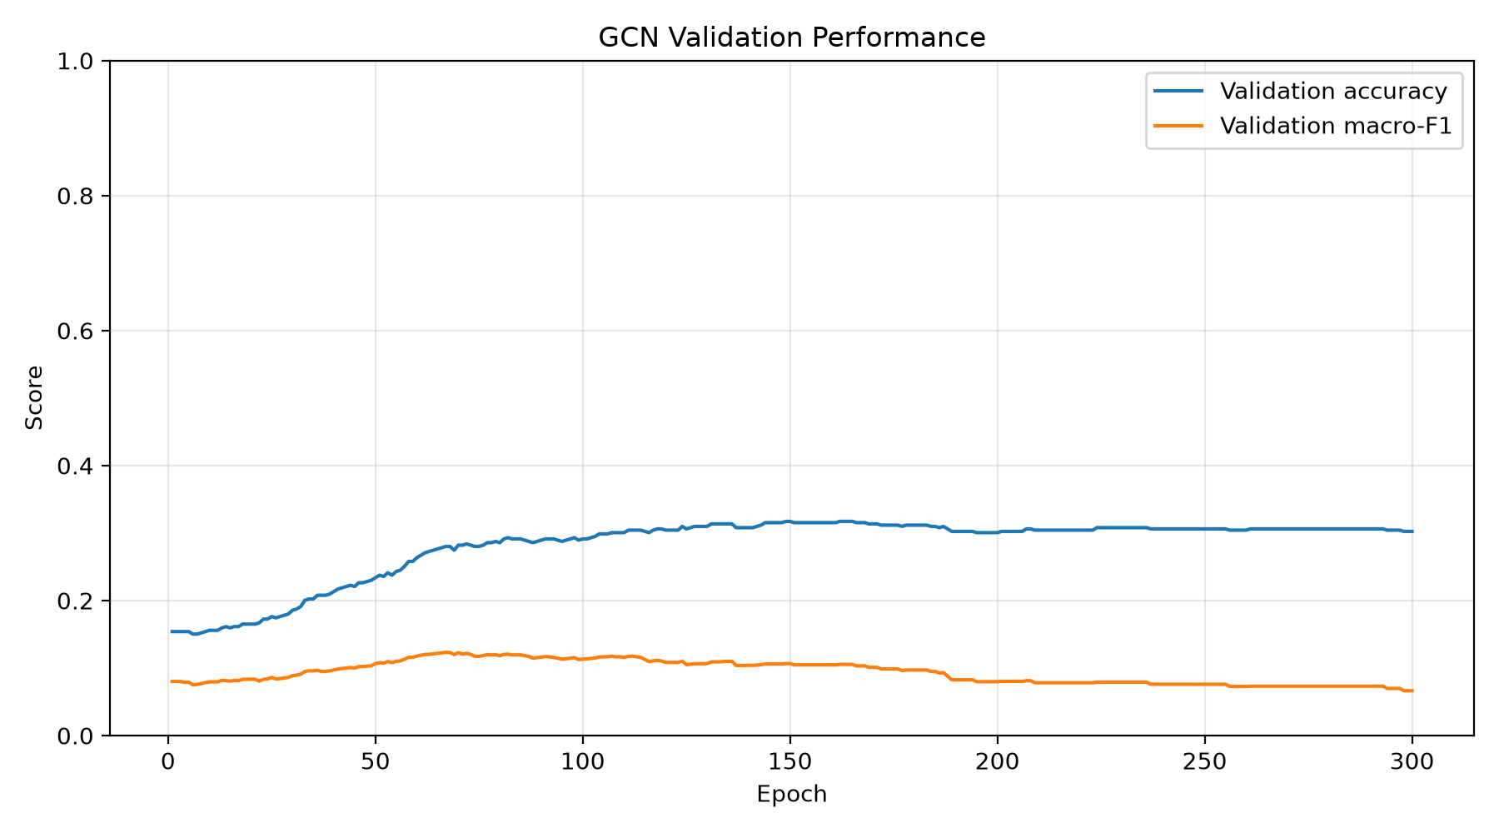
Figure 4.6. Validation accuracy and macro-F1 across training epochs.
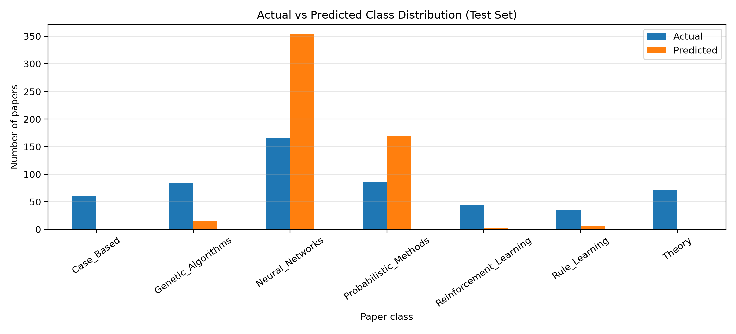
Figure 4.7. Actual versus predicted class distribution on the Cora test set.
The uploaded ZIP includes training logs and visualization images for the Cora experiment. These plots should be read alongside the test metrics: validation behavior during optimization is not the same as final held-out test performance. A model can show improving validation values yet still exhibit poor generalization or uneven class-level results.

4.7 Interpretation and limitations
- The implementation is a hand-written Java GCN, including forward propagation, loss calculation, backpropagation, parameter updates, and evaluation functions.
- The fixed seed supports repeatability of the random initialization and split logic, subject to the same runtime and input files.
- The test-set metrics derived from the saved predictions are low and uneven across classes; this should be reported transparently.
- The available saved outputs do not by themselves establish the cause of the weak class-level performance.
- Potential follow-up checks include verifying normalization and gradient calculations, inspecting the training curves, testing data-label mappings, and repeating controlled experiments; these are recommendations, not completed experiments.

4.8 Complete Two-Layer GCN source code

Listing 4.1 — Complete TwoLayerGCN.java
Source file from the uploaded project. All source lines are preserved.
import java.io.*;

import java.util.*;
public class TwoLayerGCN {

// Dataset and training configuration

static final String CONTENT_PATH = "dataset/cora/cora.content";

static final String CITES_PATH = "dataset/cora/cora.cites";

static final int HIDDEN = 32;

static final int EPOCHS = 300;

static final double LEARNING_RATE = 0.005;

static final double L2 = 0.0005;

static final long SEED = 42;

static class GraphData {

int n, features, classes;

int[][] x;

int[] y;

String[] ids;

String[] classNames;

List<Integer>[] neighbors;

List<Double>[] weights;

boolean[] train, val, test;

}

static class Model {

double[][] w0, w1;

double[][] b0, b1;
Model(int input, int hidden, int output, Random random)
w0 = new double[input][hidden];

w1 = new double[hidden][output];

b0 = new double[1][hidden];

b1 = new double[1][output];

double s0 = Math.sqrt(2.0 / input);

double s1 = Math.sqrt(2.0 / hidden);

for (int i = 0; i < input; i++)

for (int j = 0; j < hidden; j++)

w0[i][j] = random.nextGaussian() * s0;

for (int i = 0; i < hidden; i++)

for (int j = 0; j < output; j++)

w1[i][j] = random.nextGaussian() * s1;

}

}

static class Forward {

double[][] h;

double[][] probabilities;

}

public static void main(String[] args) throws Exception {

GraphData data = loadData();

System.out.println("========== CORA DATASET ==========");

System.out.println("Nodes: " + data.n);

System.out.println("Features per node: " + data.features);

System.out.println("Classes: " + data.classes);

System.out.println("Undirected graph edges (excluding self-loops): "

+ countEdges(data) / 2);

System.out.println("Training nodes: " + count(data.train));

System.out.println("Validation nodes: " + count(data.val));

System.out.println("Testing nodes: " + count(data.test));

Random random = new Random(SEED);

Model model = new Model(

data.features, HIDDEN, data.classes, random);

double bestF1 = -1;

double[][] bestW0 = null, bestW1 = null;

double[][] bestB0 = null, bestB1 = null;

try (PrintWriter log = new PrintWriter(

new FileWriter("results/training.csv"))) {

log.println("epoch,train_loss,val_accuracy,val_macro_f1");

for (int epoch = 1; epoch <= EPOCHS; epoch++) {

Forward f = forward(data, model);

double loss = loss(data, f.probabilities, data.train);

backwardAndUpdate(data, model, f, random);

Forward after = forward(data, model);

double valAcc = accuracy(

data, after.probabilities, data.val);

double valF1 = macroF1(

data, after.probabilities, data.val);

log.printf(Locale.US, "%d,%.6f,%.6f,%.6f%n",

epoch, loss, valAcc, valF1);

if (valF1 > bestF1) {

bestF1 = valF1;

bestW0 = copy(model.w0);

bestW1 = copy(model.w1);

bestB0 = copy(model.b0);

bestB1 = copy(model.b1);

}

if (epoch == 1 || epoch % 20 == 0) {

System.out.printf(Locale.US,

"Epoch %3d | Loss %.5f | Val Acc %.4f"

+ " | Val Macro-F1 %.4f%n",

epoch, loss, valAcc, valF1);

}

}

}

model.w0 = bestW0;

model.w1 = bestW1;

model.b0 = bestB0;

model.b1 = bestB1;

Forward finalPass = forward(data, model)

System.out.println("\n========== TEST RESULTS ==========");

System.out.printf(Locale.US, "Accuracy : %.4f%n",

accuracy(data, finalPass.probabilities, data.test));

System.out.printf(Locale.US, "Precision: %.4f%n",

macroPrecision(data, finalPass.probabilities, data.test));

System.out.printf(Locale.US, "Recall : %.4f%n",

macroRecall(data, finalPass.probabilities, data.test));

System.out.printf(Locale.US, "Macro-F1 : %.4f%n",

macroF1(data, finalPass.probabilities, data.test));

printClassMetrics(data, finalPass.probabilities);

printConfusionMatrix(data, finalPass.probabilities);

savePredictions(data, finalPass.probabilities);

System.out.println("\nResults saved in the results folder.");

}

// Read the Cora feature and citation files

static GraphData loadData() throws IOException {

GraphData d = new GraphData();

List<String> ids = new ArrayList<>();

List<int[]> featureRows = new ArrayList<>();

List<String> labelRows = new ArrayList<>();

Map<String, Integer> index = new HashMap<>();

TreeSet<String> labelSet = new TreeSet<>();

try (BufferedReader br = new BufferedReader(

new FileReader(CONTENT_PATH))) {

String line;

while ((line = br.readLine()) != null) {

String[] p = line.trim().split("\\s+");

if (p.length < 3) continue;

int id = ids.size();

ids.add(p[0]);

index.put(p[0], id);

int[] features = new int[p.length - 2];

for (int j = 1; j < p.length - 1; j++)

features[j - 1] = Integer.parseInt(p[j]);

featureRows.add(features);

labelRows.add(p[p.length - 1]);

labelSet.add(p[p.length - 1]);

}

}

d.n = ids.size();

d.features = featureRows.get(0).length;

d.ids = ids.toArray(new String[0]);

d.classNames = labelSet.toArray(new String[0]);

d.classes = d.classNames.length;

d.x = featureRows.toArray(new int[0][]);

d.y = new int[d.n];

Map<String, Integer> labelIndex = new HashMap<>();

for (int i = 0; i < d.classes; i++)

labelIndex.put(d.classNames[i], i);

for (int i = 0; i < d.n; i++)

d.y[i] = labelIndex.get(labelRows.get(i));

// Construct an undirected graph and add self-loops.

List<Set<Integer>> adjacency = new ArrayList<>();

for (int i = 0; i < d.n; i++) {

adjacency.add(new HashSet<>());

adjacency.get(i).add(i);

}

try (BufferedReader br = new BufferedReader(

new FileReader(CITES_PATH))) {

String line;

while ((line = br.readLine()) != null) {

String[] p = line.trim().split("\\s+");

if (p.length < 2) continue;

Integer u = index.get(p[0]);

Integer v = index.get(p[1]);

// Ignore references to IDs absent from the content file.

if (u != null && v != null) {

adjacency.get(u).add(v);

adjacency.get(v).add(u);

}

}

}

// Symmetric normalization:

// A_hat = D^(-1/2) * (A + I) * D^(-1/2)

d.neighbors = new List[d.n];

d.weights = new List[d.n];

double[] degree = new double[d.n];

for (int i = 0; i < d.n; i++)

degree[i] = adjacency.get(i).size();

for (int i = 0; i < d.n; i++) {

d.neighbors[i] = new ArrayList<>();

d.weights[i] = new ArrayList<>();

for (int j : adjacency.get(i)) {

d.neighbors[i].add(j);

d.weights[i].add(

1.0 / Math.sqrt(degree[i] * degree[j]));

}

}

makeSplits(d, new Random(SEED));

return d;

}

// Stratified split: 60% train, 20% validation, 20% test.

static void makeSplits(GraphData d, Random random) {

List<List<Integer>> byClass = new ArrayList<>();

for (int c = 0; c < d.classes; c++)

byClass.add(new ArrayList<>());

for (int i = 0; i < d.n; i++)

byClass.get(d.y[i]).add(i);

d.train = new boolean[d.n];

d.val = new boolean[d.n];

d.test = new boolean[d.n];

for (List<Integer> group : byClass) {

Collections.shuffle(group, random);

int nTrain = (int) (group.size() * 0.60);

int nVal = (int) (group.size() * 0.20);

for (int i = 0; i < group.size(); i++) {

int node = group.get(i);

if (i < nTrain) d.train[node] = true;

else if (i < nTrain + nVal) d.val[node] = true;

else d.test[node] = true;

}

}

}

// Forward pass:

// H = ReLU(A_hat * X * W0 + b0)

// P = Softmax(A_hat * H * W1 + b1)

static Forward forward(GraphData d, Model m) {

double[][] xw = new double[d.n][HIDDEN];

for (int i = 0; i < d.n; i++) {

for (int f = 0; f < d.features; f++) {

if (d.x[i][f] == 0) continue;

for (int h = 0; h < HIDDEN; h++)

xw[i][h] += d.x[i][f] * m.w0[f][h];

}

}

double[][] h = propagate(d, xw);

for (int i = 0; i < d.n; i++)

for (int j = 0; j < HIDDEN; j++)

h[i][j] = Math.max(0, h[i][j] + m.b0[0][j]);

double[][] hw = multiply(h, m.w1);

double[][] logits = propagate(d, hw);

for (int i = 0; i < d.n; i++)

for (int c = 0; c < d.classes; c++)

logits[i][c] += m.b1[0][c];

Forward result = new Forward();

result.h = h;

result.probabilities = softmax(logits);

return result;

}

// Sparse graph propagation: A_hat * matrix

static double[][] propagate(GraphData d, double[][] matrix) {

int cols = matrix[0].length;

double[][] result = new double[d.n][cols];

for (int i = 0; i < d.n; i++) {

for (int k = 0; k < d.neighbors[i].size(); k++) {

int j = d.neighbors[i].get(k);

double weight = d.weights[i].get(k);

for (int c = 0; c < cols; c++)

result[i][c] += weight * matrix[j][c];

}

}

return result;

}

// Backpropagation and gradient descent

static void backwardAndUpdate(

GraphData d, Model m, Forward f, Random random) {

double[][] gradLogits = new double[d.n][d.classes];

int trainCount = count(d.train);

for (int i = 0; i < d.n; i++) {

if (!d.train[i]) continue;

for (int c = 0; c < d.classes; c++) {

gradLogits[i][c] =

(f.probabilities[i][c]

- (d.y[i] == c ? 1.0 : 0.0))

/ trainCount;

}

}

// Output layer: logits = A_hat * H * W1 + b1

double[][] aGrad = propagate(d, gradLogits);

double[][] gradW1 = multiply(transpose(f.h), aGrad);

double[][] gradB1 = columnSums(gradLogits);

double[][] gradH = multiply(aGrad, transpose(m.w1));

// Backpropagate through ReLU

for (int i = 0; i < d.n; i++)

for (int h = 0; h < HIDDEN; h++)

if (f.h[i][h] <= 0)

gradH[i][h] = 0;

// Hidden layer: H = ReLU(A_hat * X * W0 + b0)

double[][] gradPre = propagate(d, gradH);

double[][] gradW0 = new double[d.features][HIDDEN];

for (int i = 0; i < d.n; i++) {

for (int feature = 0; feature < d.features; feature++) {

if (d.x[i][feature] == 0) continue;

for (int h = 0; h < HIDDEN; h++)

gradW0[feature][h] +=

d.x[i][feature] * gradPre[i][h];

}

}

double[][] gradB0 = columnSums(gradH);

// Weight decay applies to weights, not biases.

for (int i = 0; i < d.features; i++)

for (int h = 0; h < HIDDEN; h++)

gradW0[i][h] += L2 * m.w0[i][h];

for (int i = 0; i < HIDDEN; i++)

for (int c = 0; c < d.classes; c++)

gradW1[i][c] += L2 * m.w1[i][c];

update(m.w0, gradW0);

update(m.w1, gradW1);

update(m.b0, gradB0);

update(m.b1, gradB1);

}

static void update(double[][] weights, double[][] gradients) {

for (int i = 0; i < weights.length; i++)

for (int j = 0; j < weights[i].length; j++)

weights[i][j] -= LEARNING_RATE * gradients[i][j];

}

static double loss(

GraphData d, double[][] p, boolean[] mask) {

double total = 0;

int n = count(mask);

for (int i = 0; i < d.n; i++)

if (mask[i])

total -= Math.log(Math.max(

1e-12, p[i][d.y[i]]));

return total / n;

}

static double[][] softmax(double[][] logits) {

double[][] p = new double[logits.length][logits[0].length];

for (int i = 0; i < logits.length; i++) {

double max = Arrays.stream(logits[i]).max().orElse(0);

double sum = 0;

for (int c = 0; c < logits[i].length; c++) {

p[i][c] = Math.exp(logits[i][c] - max);

sum += p[i][c];

}

for (int c = 0; c < logits[i].length; c++)

p[i][c] /= sum;

}

return p;

}

static int predict(double[] p) {

int best = 0;

for (int c = 1; c < p.length; c++)

if (p[c] > p[best]) best = c;

return best;

}

static double accuracy(

GraphData d, double[][] p, boolean[] mask) {

int correct = 0, total = 0;

for (int i = 0; i < d.n; i++) {

if (!mask[i]) continue;

total++;

if (predict(p[i]) == d.y[i]) correct++;

}

return total == 0 ? 0 : (double) correct / total;

}

static double[][] confusionMatrix(

GraphData d, double[][] p, boolean[] mask) {

double[][] cm = new double[d.classes][d.classes];

for (int i = 0; i < d.n; i++)

if (mask[i])

cm[d.y[i]][predict(p[i])]++;

return cm;

}

static double precision(double tp, double fp) {

return tp + fp == 0 ? 0 : tp / (tp + fp);

}

static double recall(double tp, double fn) {

return tp + fn == 0 ? 0 : tp / (tp + fn);

}

static double f1(double p, double r) {

return p + r == 0 ? 0 : 2 * p * r / (p + r);

}

static double macroPrecision(

GraphData d, double[][] p, boolean[] mask) {

double[][] cm = confusionMatrix(d, p, mask);

double sum = 0;

for (int c = 0; c < d.classes; c++) {

double tp = cm[c][c], fp = 0;

for (int r = 0; r < d.classes; r++)

if (r != c) fp += cm[r][c];

sum += precision(tp, fp);

}

return sum / d.classes;

}

static double macroRecall(

GraphData d, double[][] p, boolean[] mask) {

double[][] cm = confusionMatrix(d, p, mask);

double sum = 0;

for (int c = 0; c < d.classes; c++) {

double tp = cm[c][c], fn = 0;

for (int col = 0; col < d.classes; col++)

if (col != c) fn += cm[c][col];

sum += recall(tp, fn);

}

return sum / d.classes;

}

static double macroF1(

GraphData d, double[][] p, boolean[] mask) {

double[][] cm = confusionMatrix(d, p, mask);

double sum = 0;

for (int c = 0; c < d.classes; c++) {

double tp = cm[c][c], fp = 0, fn = 0;

for (int r = 0; r < d.classes; r++) {

if (r != c) {

fp += cm[r][c];

fn += cm[c][r];

}

}

sum += f1(precision(tp, fp), recall(tp, fn));

}

return sum / d.classes;

}

static void printClassMetrics(

GraphData d, double[][] p) {

double[][] cm = confusionMatrix(d, p, d.test);

System.out.println("\nPer-class test metrics:");

System.out.println("Class\tPrecision\tRecall\t\tF1");

for (int c = 0; c < d.classes; c++) {

double tp = cm[c][c], fp = 0, fn = 0;

for (int r = 0; r < d.classes; r++) {

if (r != c) {

fp += cm[r][c];

fn += cm[c][r];

}

}

System.out.printf(Locale.US, "%s\t%.4f\t\t%.4f\t\t%.4f%n",

d.classNames[c],

precision(tp, fp),

recall(tp, fn),

f1(precision(tp, fp), recall(tp, fn)));

}

}

static void printConfusionMatrix(

GraphData d, double[][] p) {

double[][] cm = confusionMatrix(d, p, d.test);

System.out.println("\nConfusion matrix (actual rows, predicted columns):");

System.out.print("Actual\\Pred");

for (String name : d.classNames)

System.out.print("\t" + name);

System.out.println();

for (int r = 0; r < d.classes; r++) {

System.out.print(d.classNames[r]);

for (int c = 0; c < d.classes; c++)

System.out.print("\t" + (int) cm[r][c]);

System.out.println();

}

}

static void savePredictions(

GraphData d, double[][] p) throws IOException {

try (PrintWriter out = new PrintWriter(

new FileWriter("results/predictions.csv"))) {

out.println("paper_id,actual,predicted,correct_class_probability");

for (int i = 0; i < d.n; i++) {

if (!d.test[i]) continue;

int pred = predict(p[i]);

out.printf(Locale.US, "%s,%s,%s,%.6f%n",

d.ids[i], d.classNames[d.y[i]],

d.classNames[pred], p[i][d.y[i]]);

}

}

}

static int count(boolean[] values) {

int n = 0;

for (boolean v : values) if (v) n++;

return n;

}

static int countEdges(GraphData d) {

int n = 0;

for (List<Integer> list : d.neighbors)

n += list.size();

return n;

}

static double[][] multiply(double[][] a, double[][] b) {

double[][] c = new double[a.length][b[0].length];

for (int i = 0; i < a.length; i++)

for (int k = 0; k < b.length; k++) {

double value = a[i][k];

if (value == 0) continue;

for (int j = 0; j < b[0].length; j++)

c[i][j] += value * b[k][j];

}

return c;

}

static double[][] transpose(double[][] a) {

double[][] t = new double[a[0].length][a.length];

for (int i = 0; i < a.length; i++)

for (int j = 0; j < a[i].length; j++)

t[j][i] = a[i][j];

return t;

}

static double[][] columnSums(double[][] a) {

double[][] sums = new double[1][a[0].length];

for (double[] row : a)

for (int j = 0; j < row.length; j++)

sums[0][j] += row[j];

return sums;

}

static double[][] copy(double[][] a) {

double[][] b = new double[a.length][];

for (int i = 0; i < a.length; i++)

b[i] = a[i].clone();

return b;

}

}
5. Three-Layer GCN on CiteSeer
This section begins on a new page and follows the complete Two-Layer GCN section.

5.1 Experiment overview
The three-layer model is implemented in `ThreeLayerGCN.java`. It loads CiteSeer content and citation files and reports 3,312 nodes, 3,703 features per node, six classes, 1,984 training nodes, 660 validation nodes, and 668 testing nodes. The implementation uses hidden dimensions 32 and 16, 200 epochs, learning rate 0.01, L2 coefficient 0.0005, and seed 42.

5.2 Architecture
The three-layer network uses two hidden graph-convolution transformations followed by an output transformation. The first hidden layer maps input features to 32 dimensions and applies ReLU. The second hidden layer maps 32 dimensions to 16 and applies ReLU. The final layer maps the 16-dimensional representation to six class logits, which are converted into probabilities with softmax. The implementation trains with cross-entropy on training nodes and tracks validation accuracy and macro-F1.
H¹ = ReLU(Ã X W⁰ + b⁰)
H² = ReLU(Ã H¹ W¹ + b¹)
P = Softmax(Ã H² W² + b²)

5.3 Saved test results
The saved `metrics.txt` reports test accuracy 0.458084, macro precision 0.273062, macro recall 0.383816, and macro F1-score 0.303930 over 668 test nodes. These metrics are the values produced by the Java model and retained in the uploaded ZIP.
Metric | Saved value
Test nodes | 668
Accuracy | 0.4581
Macro precision | 0.2731
Macro recall | 0.3838
Macro F1-score | 0.3039

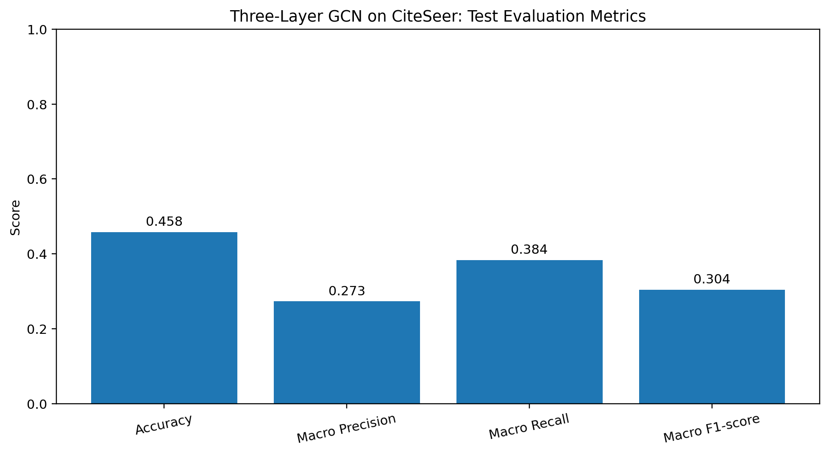
Figure 5.1. Overall CiteSeer test metrics from the saved three-layer predictions.
Interpretation: the model correctly classifies about 45.81% of the held-out test nodes. Macro recall (0.3838) is higher than macro precision (0.2731), indicating that the average fraction of true members recovered across classes is higher than the average correctness of class predictions. Macro F1 of 0.3039 reflects the trade-off between precision and recall and the uneven distribution of class-level performance
5.4 Per-class evaluation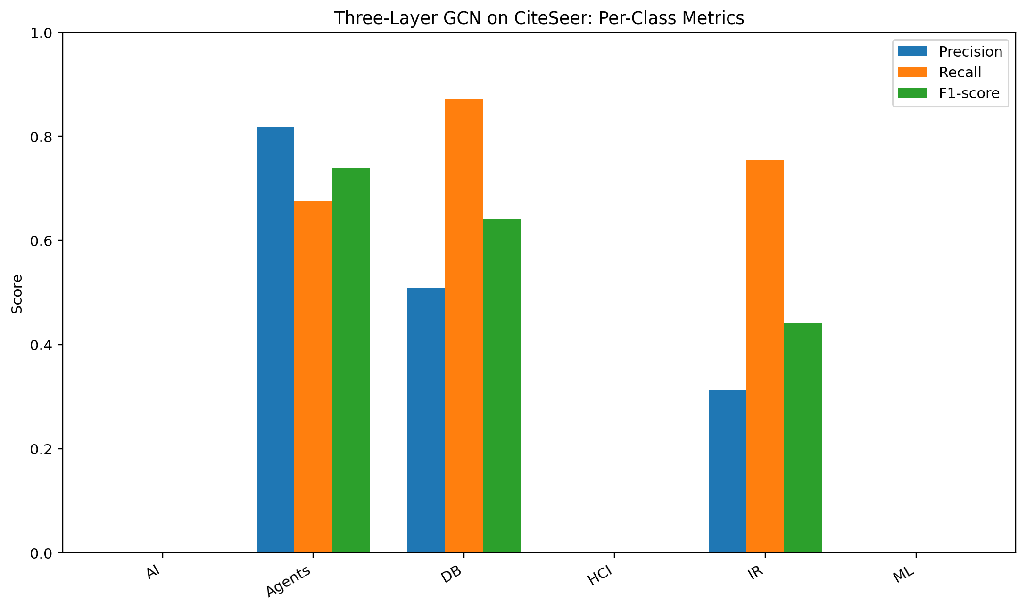
Figure 5.2. Per-class precision, recall, and F1-score for CiteSeer.
Class | Precision | Recall | F1-score
AI | 0.0000 | 0.0000 | 0.0000
Agents | 0.8182 | 0.6750 | 0.7397
DB | 0.5083 | 0.8723 | 0.6423
HCI | 0.0000 | 0.0000 | 0.0000
IR | 0.3119 | 0.7556 | 0.4416
ML | 0.0000 | 0.0000 | 0.0000

The class-wise results show that Agents and DB have the strongest F1-scores in the saved predictions. IR has moderate F1, while AI, HCI, and ML have zero F1 in the test predictions. A zero F1 means that the model did not correctly predict that class in the saved test set; it does not mean that the class is absent from the dataset.

5.5 Confusion matrix
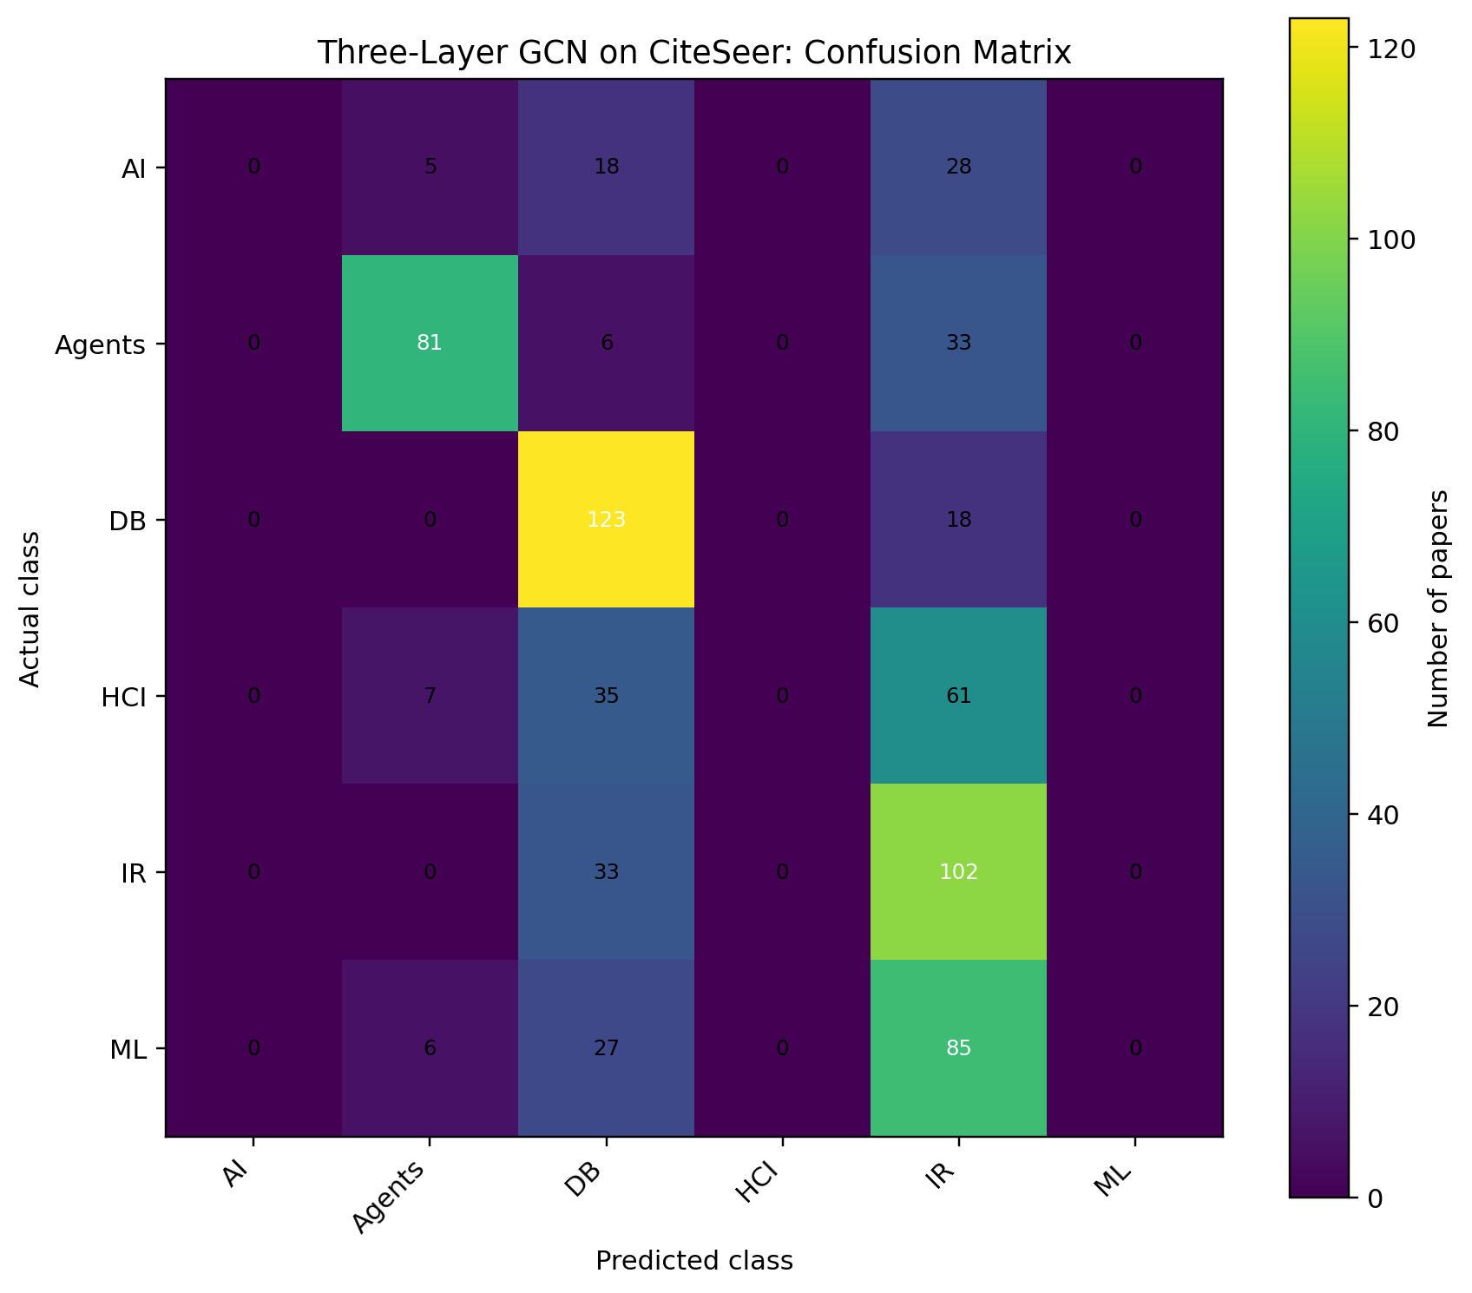
Figure 5.3. CiteSeer confusion matrix from saved predictions; actual classes are rows and predicted classes are columns.
The confusion matrix shows that predictions concentrate on Agents, DB, and IR. Many AI, HCI, and ML papers are assigned to one of those classes rather than their true class. This concentration explains why some categories have zero class-wise F1 even though overall accuracy is above 0.45. The matrix gives a more detailed account of model behavior than accuracy alone.

5.6 Training behavior
The saved training log records epoch, training loss, validation accuracy, and validation macro-F1. The source code retains the model checkpoint with the best validation macro-F1. In the console output supplied in the conversation, validation accuracy and validation macro-F1 increased over the 200 epochs, reaching 0.4485 and 0.2985 at epoch 200; final test accuracy is 0.4581 and test macro-F1 is 0.3039. The validation and test numbers refer to different subsets and should not be treated as interchangeable.

5.7 Data and implementation notes
- The Java run reported 17 citation links with unknown paper identifiers; those links were ignored by the loader.
- The graph construction is undirected and adds a self-loop for each retained node.
- The implementation uses fixed-seed stratified 60/20/20 splits.
- The reported metrics are from the saved model output and prediction file; no new model training was performed to make this report.
- The results indicate that performance is not balanced across all six CiteSeer categories.

5.8 Complete Three-Layer GCN source code

Listing 5.1 — Complete ThreeLayerGCN.java
import java.io.*;
import java.nio.file.*;
import java.util.*;

public class ThreeLayerGCN {

static final String CONTENT = "dataset/citeseer/citeseer.content";
static final String CITES = "dataset/citeseer/citeseer.cites";
static final String OUT = "results/citeseer_three_layer";

static final int H1 = 32;
static final int H2 = 16;
static final int EPOCHS = 200;

static final double LR = 0.01;
static final double L2 = 0.0005;
static final long SEED = 42;

static class Data {
int n, f, c;
String[] ids, names;
double[][] x;
int[] y;
List<Integer>[] nbr;
List<Double>[] wt;
boolean[] train, val, test;
}

static class Model {
double[][] w0, w1, w2;
double[][] b0, b1, b2;

Model(int in, int h1, int h2, int out, Random r) {
w0 = init(in, h1, r, Math.sqrt(2.0 / in));
w1 = init(h1, h2, r, Math.sqrt(2.0 / h1));
w2 = init(h2, out, r, Math.sqrt(2.0 / h2));

b0 = new double[1][h1];
b1 = new double[1][h2];
b2 = new double[1][out];
}
}

static class Fwd {
double[][] ax, u0, h0, ah0;
double[][] u1, h1, ah1, z, p;
}

public static void main(String[] args) throws Exception {

Data d = load();
Files.createDirectories(Paths.get(OUT));

System.out.println("===== CITESEER: THREE-LAYER GCN =====");
System.out.println("Nodes: " + d.n);
System.out.println("Features per node: " + d.f);
System.out.println("Classes: " + d.c);
System.out.println("Undirected citation edges: " + edgeCount(d) / 2);
System.out.println("Training nodes: " + count(d.train));
System.out.println("Validation nodes: " + count(d.val));
System.out.println("Testing nodes: " + count(d.test));

Model model = new Model(
d.f, H1, H2, d.c, new Random(SEED));

Model best = null;
double bestF1 = -1;

try (PrintWriter log = new PrintWriter(
new FileWriter(OUT + "/training.csv"))) {

log.println("epoch,train_loss,val_accuracy,val_macro_f1");

for (int epoch = 1; epoch <= EPOCHS; epoch++) {

Fwd f = forward(d, model);
double trainLoss = loss(d, f.p, d.train);

backward(d, model, f);

Fwd after = forward(d, model);

double valAccuracy = accuracy(d, after.p, d.val);
double valF1 = macroF1(d, after.p, d.val);

log.printf(Locale.US, "%d,%.8f,%.6f,%.6f%n",
epoch, trainLoss, valAccuracy, valF1);

if (valF1 > bestF1) {
bestF1 = valF1;
best = copy(model);
}

if (epoch == 1 || epoch % 20 == 0) {
System.out.printf(Locale.US,
"Epoch %3d | Loss %.4f | Validation Accuracy %.4f | Validation Macro-F1 %.4f%n",
epoch, trainLoss, valAccuracy, valF1);
}
}
}

if (best != null) {
model = best;
}

Fwd finalForward = forward(d, model);

double acc = accuracy(d, finalForward.p, d.test);
double precision = macroPrecision(d, finalForward.p, d.test);
double recall = macroRecall(d, finalForward.p, d.test);
double f1 = macroF1(d, finalForward.p, d.test);

System.out.println("\n===== TEST RESULTS =====");

System.out.printf(Locale.US, "Accuracy : %.4f%n", acc);
System.out.printf(Locale.US, "Macro Precision : %.4f%n", precision);
System.out.printf(Locale.US, "Macro Recall : %.4f%n", recall);
System.out.printf(Locale.US, "Macro F1-score : %.4f%n", f1);

printClassMetrics(d, finalForward.p);
printConfusionMatrix(d, finalForward.p);

try (PrintWriter out = new PrintWriter(
new FileWriter(OUT + "/metrics.txt"))) {

out.println("Dataset: CiteSeer");
out.println("Model: Three-layer GCN");
out.println("Nodes: " + d.n);
out.println("Features per node: " + d.f);
out.println("Classes: " + d.c);
out.println("Training nodes: " + count(d.train));
out.println("Validation nodes: " + count(d.val));
out.println("Testing nodes: " + count(d.test));

out.printf(Locale.US, "Accuracy: %.6f%n", acc);
out.printf(Locale.US, "Macro Precision: %.6f%n", precision);
out.printf(Locale.US, "Macro Recall: %.6f%n", recall);
out.printf(Locale.US, "Macro F1-score: %.6f%n", f1);
}

savePredictions(d, finalForward.p);

System.out.println("\nResults saved in: " + OUT);
}

// Load CiteSeer paper features, labels and citation edges
static Data load() throws IOException {

if (!Files.exists(Paths.get(CONTENT))
|| !Files.exists(Paths.get(CITES))) {
throw new FileNotFoundException(
"CiteSeer files not found.\nExpected:\n"
+ CONTENT + "\n" + CITES);
}

List<String[]> rows = new ArrayList<>();
TreeSet<String> labels = new TreeSet<>();
Map<String, Integer> index = new LinkedHashMap<>();

int featureCount = -1;

for (String line : Files.readAllLines(Paths.get(CONTENT))) {

line = line.trim();

if (line.isEmpty()) {
continue;
}

String[] p = line.split("\\s+");

if (p.length < 3) {
continue;
}

if (featureCount == -1) {
featureCount = p.length - 2;
}

if (p.length - 2 != featureCount) {
throw new IOException(
"Inconsistent feature count near paper " + p[0]);
}

if (index.containsKey(p[0])) {
throw new IOException("Duplicate paper ID: " + p[0]);
}

index.put(p[0], rows.size());
rows.add(p);
labels.add(p[p.length - 1]);
}

if (rows.isEmpty()) {
throw new IOException("No paper records found.");
}

Data d = new Data();

d.n = rows.size();
d.f = featureCount;
d.c = labels.size();

d.ids = new String[d.n];
d.x = new double[d.n][d.f];
d.y = new int[d.n];
d.names = labels.toArray(new String[0]);

Map<String, Integer> labelIndex = new HashMap<>();

for (int i = 0; i < d.c; i++) {
labelIndex.put(d.names[i], i);
}

for (int i = 0; i < d.n; i++) {

String[] p = rows.get(i);
d.ids[i] = p[0];

for (int j = 0; j < d.f; j++) {
d.x[i][j] = Double.parseDouble(p[j + 1]);
}

d.y[i] = labelIndex.get(p[p.length - 1]);
}

@SuppressWarnings("unchecked")
Set<Integer>[] adjacency = new Set[d.n];

for (int i = 0; i < d.n; i++) {
adjacency[i] = new TreeSet<>();
}

int unknown = 0;

for (String line : Files.readAllLines(Paths.get(CITES))) {

line = line.trim();

if (line.isEmpty()) {
continue;
}

String[] p = line.split("\\s+");

if (p.length < 2) {
continue;
}

Integer u = index.get(p[0]);
Integer v = index.get(p[1]);

if (u == null || v == null) {
unknown++;
continue;
}

if (!u.equals(v)) {
adjacency[u].add(v);
adjacency[v].add(u);
}
}

d.nbr = new List[d.n];
d.wt = new List[d.n];

double[] degree = new double[d.n];

// Add one self-loop to every node
for (int i = 0; i < d.n; i++) {
degree[i] = adjacency[i].size() + 1.0;
}

// Symmetrically normalized adjacency:
// A_hat = D^(-1/2) (A + I) D^(-1/2)
for (int i = 0; i < d.n; i++) {

d.nbr[i] = new ArrayList<>();
d.wt[i] = new ArrayList<>();

d.nbr[i].add(i);
d.wt[i].add(1.0 / degree[i]);

for (int j : adjacency[i]) {
d.nbr[i].add(j);
d.wt[i].add(
1.0 / Math.sqrt(degree[i] * degree[j]));
}
}

if (unknown > 0) {
System.out.println(
"Warning: ignored citation links with unknown paper IDs: "
+ unknown);
}

split(d, new Random(SEED));

return d;
}

// Stratified 60/20/20 split
static void split(Data d, Random random) {

d.train = new boolean[d.n];
d.val = new boolean[d.n];
d.test = new boolean[d.n];

Map<Integer, List<Integer>> groups = new TreeMap<>();

for (int i = 0; i < d.n; i++) {
groups.computeIfAbsent(
d.y[i], k -> new ArrayList<>()).add(i);
}

for (List<Integer> group : groups.values()) {

Collections.shuffle(group, random);

int n = group.size();
int trainCount = Math.max(1, (int) (n * 0.6));
int valCount = Math.max(1, (int) (n * 0.2));

if (trainCount + valCount >= n) {
trainCount = Math.max(1, n - 2);
valCount = 1;
}

for (int k = 0; k < n; k++) {

int id = group.get(k);

if (k < trainCount) {
d.train[id] = true;
} else if (k < trainCount + valCount) {
d.val[id] = true;
} else {
d.test[id] = true;
}
}
}
}

// Three-layer forward propagation
static Fwd forward(Data d, Model m) {

Fwd f = new Fwd();

// Layer 1
f.ax = aggregate(d, d.x);
f.u0 = addBias(multiply(f.ax, m.w0), m.b0);
f.h0 = relu(f.u0);

// Layer 2
f.ah0 = aggregate(d, f.h0);
f.u1 = addBias(multiply(f.ah0, m.w1), m.b1);
f.h1 = relu(f.u1);

// Layer 3: output layer
f.ah1 = aggregate(d, f.h1);
f.z = addBias(multiply(f.ah1, m.w2), m.b2);
f.p = softmax(f.z);

return f;
}

// Backpropagation and gradient-descent update
static void backward(Data d, Model m, Fwd f) {

int n = d.n;
int classes = d.c;
int trainCount = count(d.train);

double[][] dz = new double[n][classes];

for (int i = 0; i < n; i++) {
if (d.train[i]) {
for (int k = 0; k < classes; k++) {
dz[i][k] =
(f.p[i][k] - (d.y[i] == k ? 1.0 : 0.0))
/ trainCount;
}
}
}

// Layer 3 gradients
double[][] dw2 = multiply(transpose(f.ah1), dz);
addL2(dw2, m.w2);

double[][] gradH1 =
aggregate(d, multiply(dz, transpose(m.w2)));

double[][] du1 = reluBackward(gradH1, f.u1);

// Layer 2 gradients
double[][] dw1 = multiply(transpose(f.ah0), du1);
addL2(dw1, m.w1);

double[][] gradH0 =
aggregate(d, multiply(du1, transpose(m.w1)));

double[][] du0 = reluBackward(gradH0, f.u0);

// Layer 1 gradients
double[][] dw0 = multiply(transpose(f.ax), du0);
addL2(dw0, m.w0);

// Update weights and biases
update(m.w0, dw0);
update(m.w1, dw1);
update(m.w2, dw2);

update(m.b0, columnSums(du0));
update(m.b1, columnSums(du1));
update(m.b2, columnSums(dz));
}

// Graph neighbourhood aggregation
static double[][] aggregate(Data d, double[][] h) {

double[][] out = new double[d.n][h[0].length];

for (int i = 0; i < d.n; i++) {

for (int e = 0; e < d.nbr[i].size(); e++) {

int j = d.nbr[i].get(e);
double weight = d.wt[i].get(e);

for (int k = 0; k < h[j].length; k++) {
out[i][k] += weight * h[j][k];
}
}
}

return out;
}

static double[][] reluBackward(double[][] grad, double[][] u) {

double[][] out = new double[grad.length][grad[0].length];

for (int i = 0; i < grad.length; i++) {
for (int j = 0; j < grad[i].length; j++) {
out[i][j] = u[i][j] > 0 ? grad[i][j] : 0;
}
}

return out;
}

static double[][] init(
int rows, int cols, Random random, double scale) {

double[][] a = new double[rows][cols];

for (int i = 0; i < rows; i++) {
for (int j = 0; j < cols; j++) {
a[i][j] = random.nextGaussian() * scale;
}
}

return a;
}

static double[][] multiply(double[][] a, double[][] b) {

double[][] out = new double[a.length][b[0].length];

for (int i = 0; i < a.length; i++) {
for (int k = 0; k < b.length; k++) {

double value = a[i][k];

if (value == 0) {
continue;
}

for (int j = 0; j < b[0].length; j++) {
out[i][j] += value * b[k][j];
}
}
}

return out;
}

static double[][] transpose(double[][] a) {

double[][] out = new double[a[0].length][a.length];

for (int i = 0; i < a.length; i++) {
for (int j = 0; j < a[i].length; j++) {
out[j][i] = a[i][j];
}
}

return out;
}

static double[][] addBias(double[][] a, double[][] b) {

double[][] out = new double[a.length][a[0].length];

for (int i = 0; i < a.length; i++) {
for (int j = 0; j < a[i].length; j++) {
out[i][j] = a[i][j] + b[0][j];
}
}

return out;
}

static double[][] relu(double[][] a) {

double[][] out = new double[a.length][a[0].length];

for (int i = 0; i < a.length; i++) {
for (int j = 0; j < a[i].length; j++) {
out[i][j] = Math.max(0, a[i][j]);
}
}

return out;
}

static double[][] softmax(double[][] a) {

double[][] out = new double[a.length][a[0].length];

for (int i = 0; i < a.length; i++) {

double max = a[i][0];

for (int j = 1; j < a[i].length; j++) {
max = Math.max(max, a[i][j]);
}

double sum = 0;

for (int j = 0; j < a[i].length; j++) {
out[i][j] = Math.exp(a[i][j] - max);
sum += out[i][j];
}

for (int j = 0; j < a[i].length; j++) {
out[i][j] /= sum;
}
}

return out;
}

static double loss(Data d, double[][] p, boolean[] mask) {

double sum = 0;
int n = 0;

for (int i = 0; i < d.n; i++) {
if (mask[i]) {
sum -= Math.log(Math.max(1e-12, p[i][d.y[i]]));
n++;
}
}

return n == 0 ? 0 : sum / n;
}

static double accuracy(Data d, double[][] p, boolean[] mask) {

int correct = 0;
int total = 0;

for (int i = 0; i < d.n; i++) {
if (mask[i]) {
if (argmax(p[i]) == d.y[i]) {
correct++;
}
total++;
}
}

return total == 0 ? 0 : (double) correct / total;
}

static double[][] confusionMatrix(
Data d, double[][] p, boolean[] mask) {

double[][] cm = new double[d.c][d.c];

for (int i = 0; i < d.n; i++) {
if (mask[i]) {
cm[d.y[i]][argmax(p[i])]++;
}
}

return cm;
}

static double precision(double tp, double fp) {
return tp + fp == 0 ? 0 : tp / (tp + fp);
}

static double recall(double tp, double fn) {
return tp + fn == 0 ? 0 : tp / (tp + fn);
}

static double f1(double precision, double recall) {
return precision + recall == 0
? 0
: 2 * precision * recall / (precision + recall);
}

static double macroPrecision(
Data d, double[][] p, boolean[] mask) {

double[][] cm = confusionMatrix(d, p, mask);
double sum = 0;

for (int c = 0; c < d.c; c++) {

double tp = cm[c][c];
double fp = 0;

for (int r = 0; r < d.c; r++) {
if (r != c) {
fp += cm[r][c];
}
}

sum += precision(tp, fp);
}

return sum / d.c;
}

static double macroRecall(
Data d, double[][] p, boolean[] mask) {

double[][] cm = confusionMatrix(d, p, mask);
double sum = 0;

for (int c = 0; c < d.c; c++) {

double tp = cm[c][c];
double fn = 0;

for (int col = 0; col < d.c; col++) {
if (col != c) {
fn += cm[c][col];
}
}

sum += recall(tp, fn);
}

return sum / d.c;
}

static double macroF1(
Data d, double[][] p, boolean[] mask) {

double[][] cm = confusionMatrix(d, p, mask);
double sum = 0;

for (int c = 0; c < d.c; c++) {

double tp = cm[c][c];
double fp = 0;
double fn = 0;

for (int r = 0; r < d.c; r++) {
if (r != c) {
fp += cm[r][c];
fn += cm[c][r];
}
}

sum += f1(precision(tp, fp), recall(tp, fn));
}

return sum / d.c;
}

static void printClassMetrics(Data d, double[][] p) {

double[][] cm = confusionMatrix(d, p, d.test);

System.out.println("\nPer-class test metrics:");
System.out.println("Class\tPrecision\tRecall\t\tF1");

for (int c = 0; c < d.c; c++) {

double tp = cm[c][c];
double fp = 0;
double fn = 0;

for (int r = 0; r < d.c; r++) {
if (r != c) {
fp += cm[r][c];
fn += cm[c][r];
}
}

double pr = precision(tp, fp);
double re = recall(tp, fn);

System.out.printf(Locale.US,
"%s\t%.4f\t\t%.4f\t\t%.4f%n",
d.names[c], pr, re, f1(pr, re));
}
}

static void printConfusionMatrix(Data d, double[][] p) {

double[][] cm = confusionMatrix(d, p, d.test);

System.out.println(
"\nConfusion matrix (actual rows, predicted columns):");

System.out.print("Actual/Pred");

for (String name : d.names) {
System.out.print("\t" + name);
}

System.out.println();

for (int r = 0; r < d.c; r++) {

System.out.print(d.names[r]);

for (int c = 0; c < d.c; c++) {
System.out.print("\t" + (int) cm[r][c]);
}

System.out.println();
}
}

static void savePredictions(Data d, double[][] p)
throws IOException {

try (PrintWriter out = new PrintWriter(
new FileWriter(OUT + "/predictions.csv"))) {

out.println(
"paper_id,actual,predicted,correct_class_probability");

for (int i = 0; i < d.n; i++) {

if (!d.test[i]) {
continue;
}

int pred = argmax(p[i]);

out.printf(Locale.US, "%s,%s,%s,%.6f%n",
csv(d.ids[i]),
csv(d.names[d.y[i]]),
csv(d.names[pred]),
p[i][d.y[i]]);
}
}
}

static int argmax(double[] a) {

int best = 0;

for (int i = 1; i < a.length; i++) {
if (a[i] > a[best]) {
best = i;
}
}

return best;
}

static int count(boolean[] values) {

int n = 0;

for (boolean v : values) {
if (v) {
n++;
}
}

return n;
}

static int edgeCount(Data d) {

int n = 0;

for (List<Integer> list : d.nbr) {
n += list.size() - 1;
}

return n;
}

static void addL2(double[][] grad, double[][] weights) {

for (int i = 0; i < grad.length; i++) {
for (int j = 0; j < grad[i].length; j++) {
grad[i][j] += L2 * weights[i][j];
}
}
}

static void update(double[][] weights, double[][] grad) {

for (int i = 0; i < weights.length; i++) {
for (int j = 0; j < weights[i].length; j++) {
weights[i][j] -= LR * grad[i][j];
}
}
}

static double[][] columnSums(double[][] a) {

double[][] sums = new double[1][a[0].length];

for (double[] row : a) {
for (int j = 0; j < row.length; j++) {
sums[0][j] += row[j];
}
}

return sums;
}

static Model copy(Model m) {

Model q = new Model(
m.w0.length,
m.w0[0].length,
m.w1[0].length,
m.w2[0].length,
new Random(1));

q.w0 = copyMatrix(m.w0);
q.w1 = copyMatrix(m.w1);
q.w2 = copyMatrix(m.w2);

q.b0 = copyMatrix(m.b0);
q.b1 = copyMatrix(m.b1);
q.b2 = copyMatrix(m.b2);

return q;
}

static double[][] copyMatrix(double[][] a) {

double[][] b = new double[a.length][];

for (int i = 0; i < a.length; i++) {
b[i] = Arrays.copyOf(a[i], a[i].length);
}

return b;
}

static String csv(String s) {

if (s.contains(",") || s.contains("\"")) {
return "\"" + s.replace("\"", "\"\"") + "\"";
}

return s;
}
}

6. Supporting implementation files
Complete supporting code from the uploaded project.

6.1 DatasetLoader.java
This helper reads the Cora content and citation files and prints basic dataset counts. It is included in full because it is part of the supplied source folder.
Listing 6.1 — Complete DatasetLoader.java

import java.io.BufferedReader;
import java.io.FileReader;
import java.io.IOException;
import java.util.*;

public class DatasetLoader {

public static void main(String[] args) throws IOException {

String contentPath = "dataset/cora/cora.content";
String citesPath = "dataset/cora/cora.cites";

Map<String, double[]> features = new LinkedHashMap<>();
Map<String, String> labels = new LinkedHashMap<>();
List<String[]> edges = new ArrayList<>();

// Read paper features and class labels
try (BufferedReader br =
new BufferedReader(new FileReader(contentPath))) {

String line;

while ((line = br.readLine()) != null) {

String[] values = line.trim().split("\\s+");

String paperId = values[0];
int featureCount = values.length - 2;

double[] paperFeatures = new double[featureCount];

for (int i = 1; i < values.length - 1; i++) {
paperFeatures[i - 1] =
Double.parseDouble(values[i]);
}

String label = values[values.length - 1];

features.put(paperId, paperFeatures);
labels.put(paperId, label);
}
}

// Read citation edges
try (BufferedReader br =
new BufferedReader(new FileReader(citesPath))) {

String line;

while ((line = br.readLine()) != null) {

String[] values = line.trim().split("\\s+");

if (values.length >= 2) {
edges.add(new String[]{
values[0], values[1]
});
}
}
}

// Count distinct classes
Set<String> classes = new HashSet<>(labels.values());

System.out.println("========== CORA DATASET ==========");
System.out.println("Number of papers: " + features.size());
System.out.println("Features per paper: "
+ features.values().iterator().next().length);
System.out.println("Citation connections: " + edges.size());
System.out.println("Number of classes: " + classes.size());

System.out.println("==================================");
}
}

6.2 visualize_gcn.py
This script reads the Cora training and prediction CSV files and generates the training-loss curve, validation metrics, confusion matrix, and actual-versus-predicted class distribution. It also prints a classification report. The complete script is reproduced below.
from pathlib import Path
import pandas as pd
import matplotlib.pyplot as plt
from sklearn.metrics import confusion_matrix, ConfusionMatrixDisplay, classification_report

RESULTS = Path('results')
RESULTS.mkdir(exist_ok=True)

training_file = RESULTS / 'training.csv'
predictions_file = RESULTS / 'predictions.csv'

if not training_file.exists() or not predictions_file.exists():
raise FileNotFoundError(
'Could not find results/training.csv and results/predictions.csv. '
'Run TwoLayerGCN.java first from the project root.'
)

training = pd.read_csv(training_file)
predictions = pd.read_csv(predictions_file)

# 1. Training loss curve
plt.figure(figsize=(9, 5))
plt.plot(training['epoch'], training['train_loss'], label='Training loss')
plt.xlabel('Epoch')
plt.ylabel('Cross-entropy loss')
plt.title('GCN Training Loss')
plt.grid(True, alpha=0.3)
plt.legend()
plt.tight_layout()
plt.savefig(RESULTS / 'training_loss.png', dpi=200)
plt.close()

# 2. Validation metrics across epochs
plt.figure(figsize=(9, 5))
plt.plot(training['epoch'], training['val_accuracy'], label='Validation accuracy')
plt.plot(training['epoch'], training['val_macro_f1'], label='Validation macro-F1')
plt.xlabel('Epoch')
plt.ylabel('Score')
plt.title('GCN Validation Performance')
plt.ylim(0, 1)
plt.grid(True, alpha=0.3)
plt.legend()
plt.tight_layout()
plt.savefig(RESULTS / 'validation_metrics.png', dpi=200)
plt.close()

# 3. Test-set confusion matrix
labels = sorted(set(predictions['actual']).union(set(predictions['predicted'])))
cm = confusion_matrix(predictions['actual'], predictions['predicted'], labels=labels)
display = ConfusionMatrixDisplay(confusion_matrix=cm, display_labels=labels)
fig, ax = plt.subplots(figsize=(10, 8))
display.plot(ax=ax, xticks_rotation=45, values_format='d', colorbar=False)
ax.set_title('Cora Test Set Confusion Matrix')
fig.tight_layout()
fig.savefig(RESULTS / 'confusion_matrix.png', dpi=200)
plt.close(fig)

# 4. Actual vs predicted class counts
actual_counts = predictions['actual'].value_counts().sort_index()
predicted_counts = predictions['predicted'].value_counts().reindex(actual_counts.index, fill_value=0)
counts = pd.DataFrame({'Actual': actual_counts, 'Predicted': predicted_counts})
ax = counts.plot(kind='bar', figsize=(11, 5))
ax.set_title('Actual vs Predicted Class Distribution (Test Set)')
ax.set_xlabel('Paper class')
ax.set_ylabel('Number of papers')
ax.tick_params(axis='x', rotation=35)
ax.grid(axis='y', alpha=0.3)
plt.tight_layout()
plt.savefig(RESULTS / 'class_distribution.png', dpi=200)
plt.close()

print('Visualizations saved in results/:')
for name in ['training_loss.png', 'validation_metrics.png', 'confusion_matrix.png', 'class_distribution.png']:
print(f' - {name}')
print('\nTest-set classification report:')
print(classification_report(predictions['actual'], predictions['predicted'], zero_division=0))

6.3 print_results.py
This script reads the saved CiteSeer prediction and metrics files, computes evaluation metrics, and generates the overall metric plot, per-class metric plot, and confusion matrix in `results2`. The complete script from the uploaded ZIP is reproduced below.

from pathlib import Path
import csv
import re
import matplotlib.pyplot as plt

BASE_DIR = Path(__file__).resolve().parent
SOURCE_DIR = BASE_DIR / "results" / "citeseer_three_layer"
OUTPUT_DIR = BASE_DIR / "results2"
OUTPUT_DIR.mkdir(parents=True, exist_ok=True)

PREDICTIONS_FILE = SOURCE_DIR / "predictions.csv"
METRICS_FILE = SOURCE_DIR / "metrics.txt"

# Check that existing model results are available
if not PREDICTIONS_FILE.exists():
raise FileNotFoundError(
f"Could not find predictions.csv at:\n{PREDICTIONS_FILE}"
)

# Read the saved predictions
with open(PREDICTIONS_FILE, "r", encoding="utf-8-sig", newline="") as f:
reader = csv.DictReader(f)
rows = list(reader)

if not rows:
raise ValueError("predictions.csv is empty.")

# Find columns without depending on capitalization
columns = {c.strip().lower(): c for c in rows[0].keys() if c}

actual_col = next(
(columns[k] for k in columns if k in ("actual", "actual_class", "true_label", "true")),
None
)
predicted_col = next(
(columns[k] for k in columns if k in ("predicted", "predicted_class", "predicted_label", "prediction")),
None
)

if actual_col is None or predicted_col is None:
raise ValueError(
"Could not identify actual and predicted columns. "
f"Found columns: {list(rows[0].keys())}"
)

actual = [row[actual_col].strip().strip('"') for row in rows]
predicted = [row[predicted_col].strip().strip('"') for row in rows]

# Use a consistent class order
classes = sorted(set(actual) | set(predicted))
n = len(actual)

# Calculate confusion matrix
matrix = [[0 for _ in classes] for _ in classes]
for a, p in zip(actual, predicted):
matrix[classes.index(a)][classes.index(p)] += 1

# Calculate per-class precision, recall and F1
class_metrics = {}
for i, label in enumerate(classes):
tp = matrix[i][i]
fp = sum(matrix[r][i] for r in range(len(classes))) - tp
fn = sum(matrix[i]) - tp

precision = tp / (tp + fp) if tp + fp else 0
recall = tp / (tp + fn) if tp + fn else 0
f1 = (
2 * precision * recall / (precision + recall)
if precision + recall else 0
)
class_metrics[label] = (precision, recall, f1)

# Overall accuracy calculated from saved predictions
accuracy = sum(a == p for a, p in zip(actual, predicted)) / n

# Macro metrics calculated from the per-class values
macro_precision = sum(m[0] for m in class_metrics.values()) / len(classes)
macro_recall = sum(m[1] for m in class_metrics.values()) / len(classes)
macro_f1 = sum(m[2] for m in class_metrics.values()) / len(classes)

# Prefer the model's recorded evaluation metrics if available
if METRICS_FILE.exists():
text = METRICS_FILE.read_text(encoding="utf-8", errors="replace")
for name, variable in [
("Accuracy", "accuracy"),
("Macro Precision", "macro_precision"),
("Macro Recall", "macro_recall"),
("Macro F1-score", "macro_f1"),
]:
match = re.search(
rf"{re.escape(name)}\s*[:=]\s*([0-9]*\.?[0-9]+)",
text,
re.IGNORECASE
)
if match:
value = float(match.group(1))
if variable == "accuracy":
accuracy = value
elif variable == "macro_precision":
macro_precision = value
elif variable == "macro_recall":
macro_recall = value
elif variable == "macro_f1":
macro_f1 = value

# 1. Overall evaluation metrics
metric_names = ["Accuracy", "Macro Precision", "Macro Recall", "Macro F1-score"]
metric_values = [
accuracy, macro_precision, macro_recall, macro_f1
]

plt.figure(figsize=(9, 5))
bars = plt.bar(metric_names, metric_values)
plt.ylim(0, 1)
plt.ylabel("Score")
plt.title("Three-Layer GCN - Overall Evaluation Metrics")
plt.xticks(rotation=12)
plt.bar_label(bars, fmt="%.3f", padding=3)
plt.tight_layout()
plt.savefig(OUTPUT_DIR / "evaluation_metrics.png", dpi=300)
plt.close()

# 2. Per-class evaluation metrics
plt.figure(figsize=(10, 6))
x = list(range(len(classes)))
width = 0.25

plt.bar(
[i - width for i in x],
[class_metrics[c][0] for c in classes],
width, label="Precision"
)
plt.bar(
x,
[class_metrics[c][1] for c in classes],
width, label="Recall"
)
plt.bar(
[i + width for i in x],
[class_metrics[c][2] for c in classes],
width, label="F1-score"
)

plt.xticks(x, classes)
plt.ylim(0, 1)
plt.xlabel("CiteSeer Class")
plt.ylabel("Score")
plt.title("Three-Layer GCN - Per-Class Evaluation Metrics")
plt.legend()
plt.tight_layout()
plt.savefig(OUTPUT_DIR / "per_class_metrics.png", dpi=300)
plt.close()

# 3. Confusion matrix
plt.figure(figsize=(8, 7))
plt.imshow(matrix, interpolation="nearest")
plt.title("Three-Layer GCN - Confusion Matrix")
plt.colorbar(label="Number of Papers")
plt.xticks(range(len(classes)), classes, rotation=45, ha="right")
plt.yticks(range(len(classes)), classes)
plt.xlabel("Predicted Class")
plt.ylabel("Actual Class")

threshold = max(max(row) for row in matrix) / 2 if matrix else 0
for i in range(len(classes)):
for j in range(len(classes)):
plt.text(
j, i, str(matrix[i][j]),
ha="center", va="center",
color="white" if matrix[i][j] > threshold else "black"
)

plt.tight_layout()
plt.savefig(OUTPUT_DIR / "confusion_matrix.png", dpi=300)
plt.close()

print("\nThree-Layer GCN Evaluation PNGs created successfully!")
print("Saved in:", OUTPUT_DIR)
print("\nOverall Metrics:")
for name, value in zip(metric_names, metric_values):
print(f"{name}: {value:.4f}")

print("\nGenerated files:")
print("1. evaluation_metrics.png")
print("2. per_class_metrics.png")
print("3. confusion_matrix.png")
7. Overall discussion and limitations

7.1 Summary of saved evaluation
Experiment | Dataset | Test nodes | Accuracy | Macro precision | Macro recall | Macro F1
Two-Layer GCN | Cora | 548 | 0.2573 | 0.0852 | 0.1579 | 0.1048
Three-Layer GCN | CiteSeer | 668 | 0.4581 | 0.2731 | 0.3838 | 0.3039

The two-layer Cora prediction file yields lower overall accuracy and macro-F1 than the saved three-layer CiteSeer result. However, this is not a fair direct comparison of layer depth: the experiments use different datasets, class counts, feature dimensions, training durations, hidden dimensions, and learning rates. The comparison is descriptive only.

7.2 Main observations
- Both implementations use the Vanilla GCN pattern of graph propagation, trainable linear transformations, nonlinear hidden activations, and a softmax output.
- The model code is implemented directly in Java rather than relying on a high-level graph learning library.
- The code creates graph splits and evaluates only test-mask nodes for final predictions.
- The Cora test predictions show particularly weak performance on several classes and an overall accuracy of about 0.2573.
- The CiteSeer test predictions reach accuracy about 0.4581, but class-wise performance remains uneven, with three classes having zero F1 in the saved prediction file.
- Saved prediction files make it possible to reconstruct confusion matrices and class-level metrics without retraining.

7.3 Limitations
- Results depend on the specific dataset files, graph construction, train/validation/test split, and hyperparameters.
- The saved Cora predictions indicate weak class-level generalization; the available files do not prove a single cause.
- The CiteSeer model has zero F1 for AI, HCI, and ML in the saved test predictions, showing that aggregate metrics can hide class failures.
- Because the datasets and hyperparameters differ, these experiments do not isolate the causal effect of adding a GCN layer.
- The report analyzes existing artifacts and does not claim additional controlled experiments, statistical significance tests, or independent replication.

7.4 Future work
- Verify the complete forward and backward propagation implementation with small synthetic graphs where expected outputs can be checked manually.
- Run controlled repeated experiments using identical split protocols and comparable hyperparameter tuning before making claims about depth.
- Investigate class-level errors, label mapping, training stability, and class distribution using the saved CSV files.
- Compare the Vanilla GCN with alternative graph methods only if this is explicitly required as a future experiment.
- Add model checkpoints and environment/version details to improve reproducibility.

8. Conclusion
This project implements two graph convolutional network variants for semi-supervised paper classification: a two-layer Vanilla GCN on Cora and a three-layer Vanilla GCN on CiteSeer. The implementations load citation data, construct graph connectivity, normalize adjacency, train with supervised labels, monitor validation performance, and evaluate held-out test nodes. The report includes the original source files and the supporting scripts from the supplied ZIP, together with figures and metrics reconstructed from saved predictions.
The saved results show that the two-layer Cora model has low test accuracy and uneven class-level performance. The three-layer CiteSeer model obtains higher saved test accuracy but still struggles on several classes, as shown by its macro metrics and confusion matrix. These outcomes should be reported transparently. Since the experiments differ in dataset and configuration, they cannot by themselves establish that the extra layer causes the difference in performance. The main outcome is a documented implementation and evaluation workflow with clear evidence of both successful execution and areas requiring further investigation.

